BEFORE INSTALLATION:
Please carefully read the instructions for easy installation, which will help to prevent any damage to your vehicle.
The information shown here is for reference only and may differ from the product that you receive, however the goods are fitted in the same way.

INSTALLATION DIAGRAM
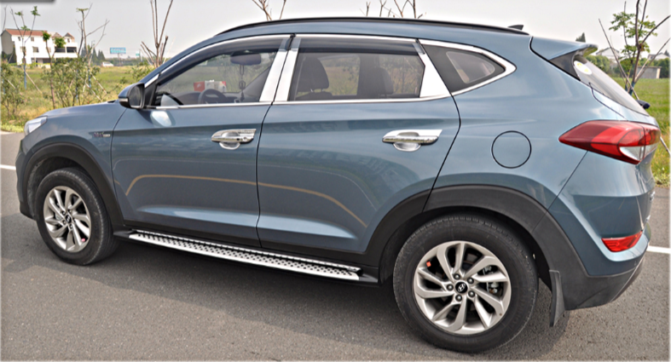

PARTS LIST:
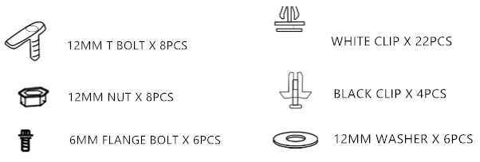
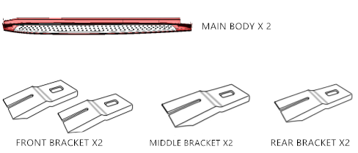

INSTALLATION PROCEDURES:
Step 1：remove the original side skirt
Step 2：remove the rubber plug of the 4 bigger weep holes under the chassis, and insert 12MM T bolts
Step 3：fix the white clips inside of the main body of running board.
Step 4：Install the bracket ,and fix it by 12MM T bolts .
Step 5：use the black clips and original self-tapping bolts to fix the end cap of running board.
Step 6：Fasten all the hardware and finish the installation.

INSTALLATION DRAWING FOR LEFT SIDE, SAME AS THE RIGHT SIDE .

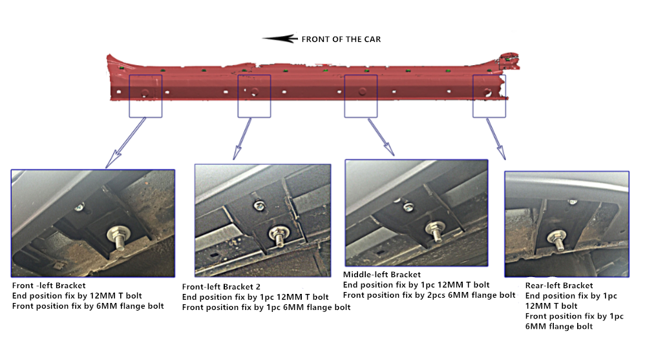

NOTE：
Regularly inspect the boards and fixings to make sure that all hardware is secure and tight.
Any damages and losses caused by improper installation and application, goes beyond our quality warranty.

